(Q) what is jQuery?

A. jQuery is a JavaScript library that makes it easier to use JavaScript on your website. It simplifies

Tasks like HTML DOM manipulation, event handing, animation , and Ajax.

(Q) How to apply CSS using jQuery, How to add Class and Remove Class in jQuery, jQuery Animation?

A. CSS use in jQuery

You can use the jQuery.CSS() method to get or set CSS properties for selected elements, you can change the background color, font size, or margin of an element using this method.

CSS input:

<!DOCTYPE html>

<html lang="en">

<head>

    <meta charset="UTF-8">

    <meta name="viewport" content="width=device-width, initial-scale=1.0">

    <title>Document</title>

    <script src="https://cdnjs.cloudflare.com/ajax/libs/jquery/3.7.0/jquery.min.js"></script>

</head>

<body>

    <div>tops education</div>

    <button>xyz</button>

      <script>

        $(document).ready(function () {

            $("button").click(function () {

                $("div").css({"background-color":"black","font-size":"100px","color":"white"})

            })

        })

      </script>

</body>

</html>

CSS output:



B. Add class and remove class…

You can use the jQuery. addClass() and jQuery.removeClass() method to add or remove classes from selected elements.

Add class input-

<!DOCTYPE html>

<html lang="en">

<head>

    <meta charset="UTF-8">

    <meta name="viewport" content="width=device-width, initial-scale=1.0">

    <title>Document</title>

    <script src="https://cdnjs.cloudflare.com/ajax/libs/jquery/3.7.0/jquery.min.js"></script>

    <style>

        .one{

            background-color: black;

            color: white;

            font-size: 100px;

        }

    </style>

</head>

<body>

    <div>tops education</div>

    <button>xyz</button>

      <script>

        $(document).ready(function () {

            $("button").click(function () {

                $("div").addClass("one")

            })

        })

      </script>

</body>

</html>

Add class output-



Remove class input-

<!DOCTYPE html>

<html lang="en">

<head>

    <meta charset="UTF-8">

    <meta name="viewport" content="width=device-width, initial-scale=1.0">

    <title>Document</title>

    <script src="https://cdnjs.cloudflare.com/ajax/libs/jquery/3.7.0/jquery.min.js"></script>

    <style>

        .one{

            background-color: black;

            color: white;

            font-size: 100px;

        }

    </style>

</head>

<body>

    <div class="one">tops education</div>

    <button>xyz</button>

      <script>

        $(document).ready(function () {

            $("button").click(function () {

                $("div").removeClass("one")

            })

        })

      </script>

</body>

</html>

Remove class output-

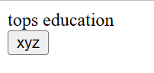

C. Animation in jQuery…..

You can use the jQuery.animate() method to create custom animations using CSS properties.

Animation input-

<!DOCTYPE html>

<html lang="en">

<head>

    <meta charset="UTF-8">

    <meta name="viewport" content="width=device-width, initial-scale=1.0">

    <title>Document</title>

    <script src="https://cdnjs.cloudflare.com/ajax/libs/jquery/3.7.0/jquery.min.js"></script>

    <style>

        div{

            height: 100px;

            width: 100px;

            background-color: black;

            position: relative;

        }

    </style>

</head>

<body>

    <div></div>

    <button>xyz</button>

      <script>

        $(document).ready(function () {

            $("button").click(function () {

                $("div").animate({"left":"20%"})

            })

        })

      </script>

</body>

</html>

Before animation output:



After animation output:



(Q) How to create slider with animation?

You can create slider with animation in jQuery using the ‘.slideToggle()’ , ‘.slideUp()’ , ‘.slideDown()’ method and some CSS properties.

Input-

<!DOCTYPE html>

<html lang="en">

<head>

    <meta charset="UTF-8">

    <meta name="viewport" content="width=device-width, initial-scale=1.0">

    <title>Document</title>

    <script src="https://cdnjs.cloudflare.com/ajax/libs/jquery/3.7.0/jquery.min.js"></script>

</head>

<body>

   <div class="slider">

    <img src="https://th.bing.com/th?id=OIP.WZpJWGQijdTLdd6E2ZaDUAHaFj&w=288&h=216&c=8&rs=1&qlt=90&o=6&pid=3.1&rm=2" alt="">

    <img src="https://th.bing.com/th?id=OIP.RtMOLmPJxYLAvaFp7-U7SgHaJQ&w=223&h=279&c=8&rs=1&qlt=90&o=6&pid=3.1&rm=2" alt="">

    <img src="https://th.bing.com/th?id=OIP.WpRmFAMvZIWjJQW3TGSktgHaEo&w=316&h=197&c=8&rs=1&qlt=90&o=6&pid=3.1&rm=2" alt="">

   </div>

   <script>

    $(document).ready(function () {

        var $slider = $('.slider');

        var $slides = $slider.find('img');

        var currentslide = 0;

        function showslide(index) {

            $slides.eq(index).css('opacity', 1);

            $slides.not(':eq(' + index +')').css('opacity', 0);

        }

        function nextslide() {

            currentslide = (currentslide + 1) % $slides.length;

            showslide(currentslide);

        }

       setInterval(nextslide, 3000); // change slide every 3 seconds

    });

   </script>

</body>

</html>

Output-

Before slide-

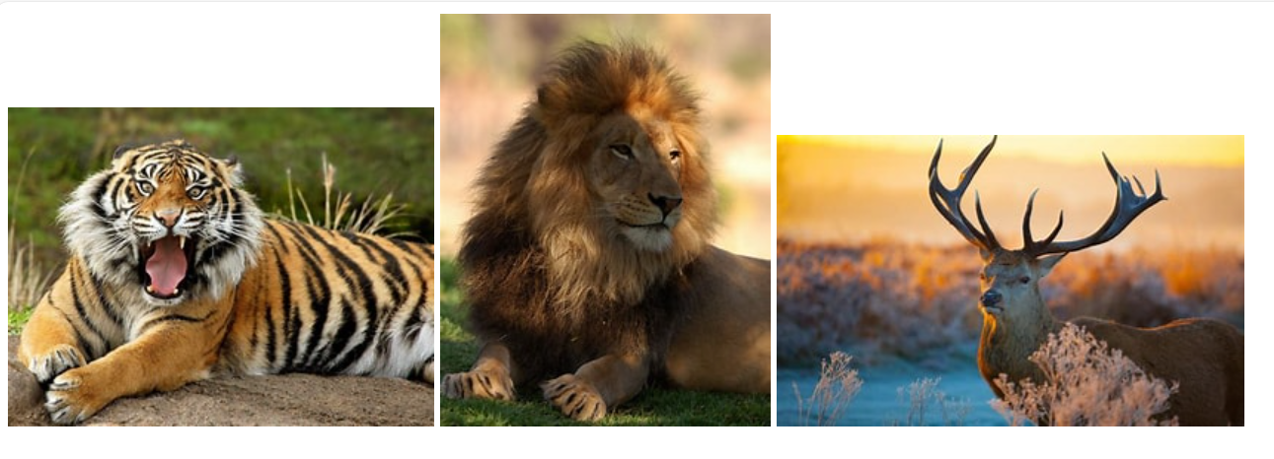

After slide-



(Q) Event bubbling tickling example

Input-

<!DOCTYPE html>

<html lang="en">

<head>

    <meta charset="UTF-8">

    <meta name="viewport" content="width=device-width, initial-scale=1.0">

    <title>Document</title>

    <script src="https://cdnjs.cloudflare.com/ajax/libs/jquery/3.7.0/jquery.min.js"></script>

    <script>

        $(document).ready(function () {

            $("span").parents().css({"border":"2px solid red"})

        })

    </script>

    <style>

         body \*{

            border: 2px solid black;

            padding: 10px;

            display: block;

         }

    </style>

</head>

<body>

    <div>

        <ul>

            <li>

                <span></span>

            </li>

        </ul>

    </div>

</body>

</html>

Output-

